WEEK 1
TEST DRIVEN DEVELOPMENT AND LOGGING FRAMEWORK
Exercise 1: Setting Up JUnit
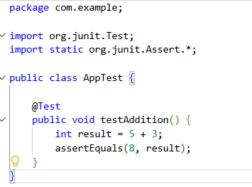
Output
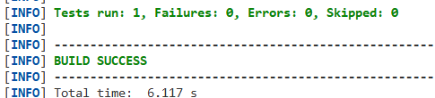
Exercise 3: Assertions in JUnit
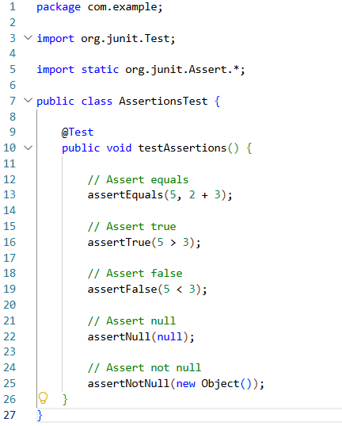
Output
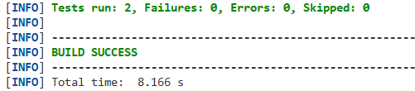
Exercise 4: Arrange-Act-Assert (AAA) Pattern, Test Fixtures, Setup and Teardown Methods in JUnit
Calculator.java
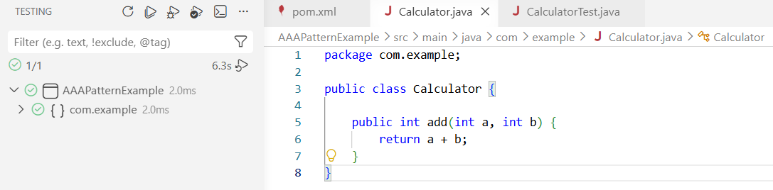
CalculatorTest.java
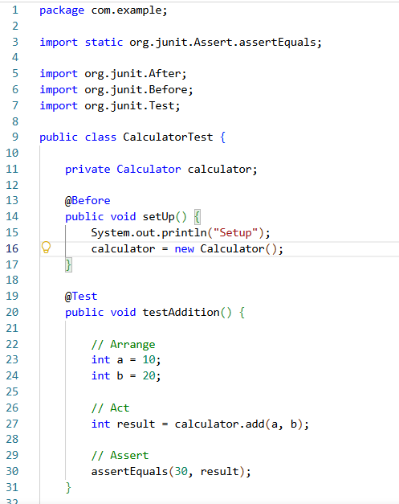
Output
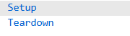
Exercise 1: Mocking and Stubbing
MyServiceTest.java
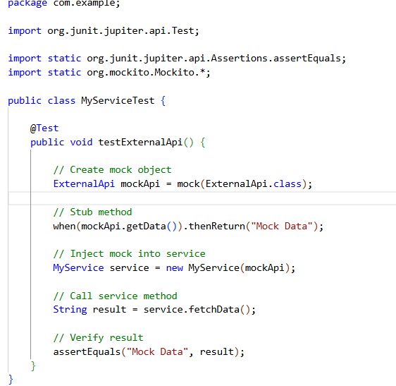
MyService.java
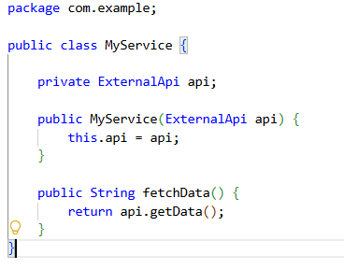
ExternalApi.java
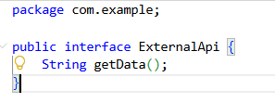
Output
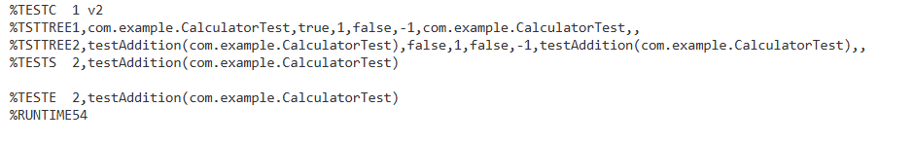
Exercise 2: Verifying Interactions
VerifyInteractionTest.java
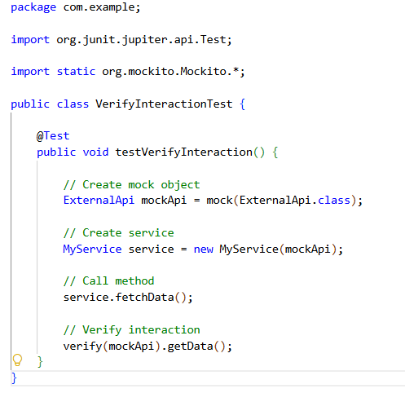
Output
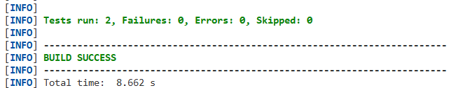
Exercise 1: Logging Error Messages and Warning Levels
LoggingExample.java
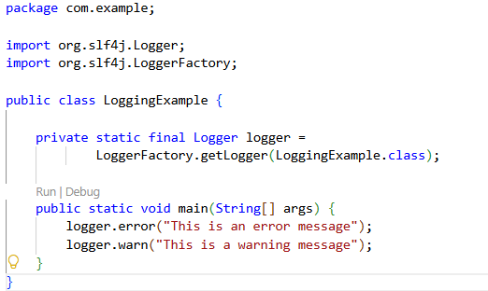
Output
